AI Assistant Coding
Assignment-17.3

Name: V.Praneeth
Roll no : 2303A52146
Batch : 41

Task-1: Employee Dataset Cleaning
Use AI assistance to clean an employee information dataset.

Prompt:
Clean and preprocess an employee dataset to make it suitable for analysis. Handle missing values in key fields such as salary, designation, and experience using appropriate techniques . Identify and remove duplicate records based on employee ID to ensure data uniqueness. Standardize job titles by converting all designation values to lowercase for consistency. Additionally, transform categorical variables like designation and employment type into numerical format using suitable encoding methods.

Before Preprocessing:

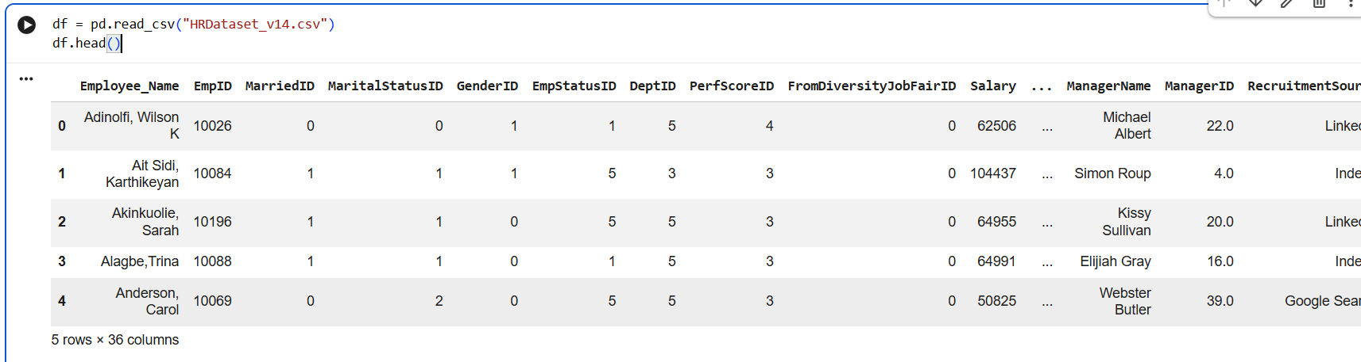

Code:

import pandas as pd
from sklearn.preprocessing import LabelEncoder

# Load dataset
df = pd.read_csv("HRDataset_v14.csv")

# Handle missing values
df['Salary'] = df['Salary'].fillna(df['Salary'].median())
df['Position'] = df['Position'].fillna("unknown")

# Remove duplicates based on Employee ID
df = df.drop_duplicates(subset='EmpID')

# Standardize text (lowercase)
df['Position'] = df['Position'].str.lower()

# Encode categorical features
le = LabelEncoder()
df['Position_encoded'] = le.fit_transform(df['Position'])
df['EmploymentStatus_encoded'] = le.fit_transform(df['EmploymentStatus'])

# Save cleaned dataset
df.to_csv("clean_employee_data.csv", index=False)

df.head()

Output:
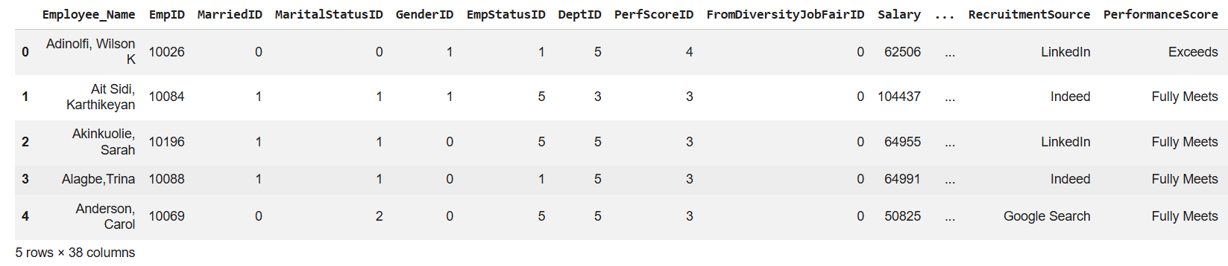

Explanation:
This task focuses on preparing employee data by handling missing values in important fields like salary, designation, and experience to ensure data completeness. Duplicate employee IDs are removed to maintain data integrity, and job titles are standardized for consistency. Finally, categorical features are encoded so the dataset becomes suitable for HR analytics and machine learning models.

Task 2: Student Performance Data Preprocessing
Preprocess student performance data using AI assistance.
Prompt:
Preprocess student performance data by converting exam dates to datetime and extracting features like month, semester, and day. Normalize total marks and identify outliers using methods such as IQR or Z-score. Prepare the dataset for analysis and modeling.

Before Preprocessing:
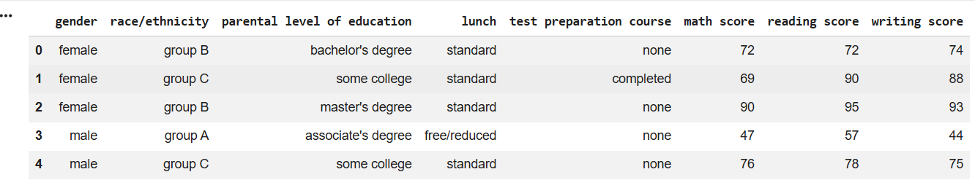
Code:
import pandas as pd
import numpy as np
from sklearn.preprocessing import MinMaxScaler

# Load dataset
df = pd.read_csv("StudentsPerformance.csv")

# Create fake exam_date (if not present)
df['exam_date'] = pd.date_range(start='2023-01-01', periods=len(df), freq='D')

# Convert to datetime
df['exam_date'] = pd.to_datetime(df['exam_date'])

# Extract features
df['month'] = df['exam_date'].dt.month
df['day'] = df['exam_date'].dt.day
df['semester'] = df['month'].apply(lambda x: 1 if x <= 6 else 2)

# Total marks
df['total_marks'] = df[['math score', 'reading score', 'writing score']].sum(axis=1)

# Normalize marks
scaler = MinMaxScaler()
df['total_marks_normalized'] = scaler.fit_transform(df[['total_marks']])

# Outlier removal using IQR
Q1 = df['total_marks'].quantile(0.25)
Q3 = df['total_marks'].quantile(0.75)
IQR = Q3 - Q1

df = df[(df['total_marks'] >= Q1 - 1.5 * IQR) &
(df['total_marks'] <= Q3 + 1.5 * IQR)]

df.to_csv("processed_student_data.csv", index=False)

df.head()

Output:
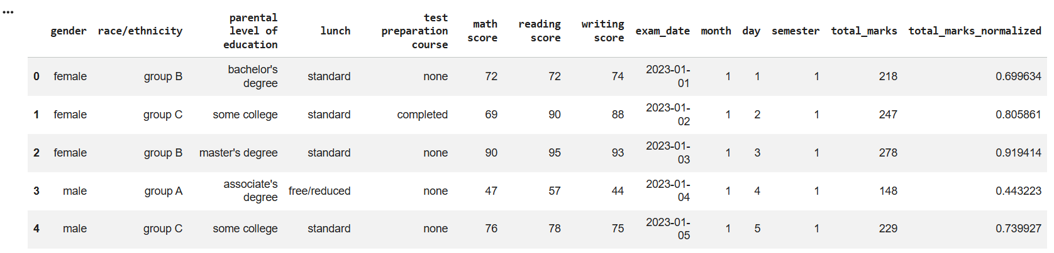

Explanation:
This task involves transforming raw student performance data into a structured format by converting exam dates into datetime and extracting useful features like month, day, and semester. It also includes normalizing total marks to bring values into a consistent range and detecting outliers using statistical methods. These steps improve data quality and make it ready for analysis and predictive modeling.
Task 3: Student Health Data Preparation
Clean and preprocess student health records using AI scripts.
Prompt:
Clean student health records by handling missing values in height, weight, and BMI. Encode categorical variables such as medical condition and fitness status, then scale numerical features using standard scaling. Finally, split the dataset into training and testing sets for predictive analysis.
Before Preprocessing:
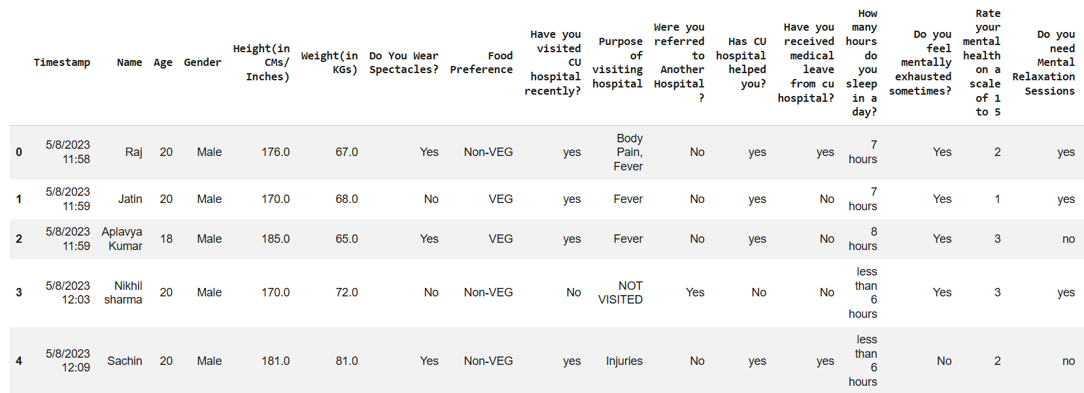
Code:
import pandas as pd
from sklearn.preprocessing import LabelEncoder, StandardScaler
from sklearn.model_selection import train_test_split

# Load dataset
df = pd.read_csv("/content/Student Health.csv")
# Clean column names: strip whitespace and convert to lowercase
df.columns = df.columns.str.strip().str.lower()

# Rename specific columns after general cleaning
# 'bmi', 'medical_condition', 'fitness_status' should already be correctly named
# after lowercasing and stripping
df = df.rename(columns={
'height(in cms/ inches)': 'height',
'weight(in kgs)': 'weight',
'purpose of visiting hospital': 'medical_condition',
'do you need mental relaxation sessions': 'fitness_status'
}, errors='ignore') # Use errors='ignore' to prevent error if a key is not found

# Handle missing values
df['height'] = df['height'].fillna(df['height'].mean())
df['weight'] = df['weight'].fillna(df['weight'].mean())
df['bmi'] = df['bmi'].fillna(df['bmi'].mean())

# Encode categorical features
le = LabelEncoder()
df['medical_condition_encoded'] = le.fit_transform(df['medical_condition'])
df['fitness_status_encoded'] = le.fit_transform(df['fitness_status'])

# Scale numerical features
scaler = StandardScaler()
df[['height', 'weight', 'bmi']] = scaler.fit_transform(df[['height', 'weight', 'bmi']])

# Split dataset
X = df.drop(columns=['fitness_status', 'medical_condition'])
y = df['fitness_status_encoded']

X_train, X_test, y_train, y_test = train_test_split(
X, y, test_size=0.2, random_state=42
)

print(X_train.head())
print(y_train.head())
print("Train shape:", X_train.shape)
print("Test shape:", X_test.shape)
Output:
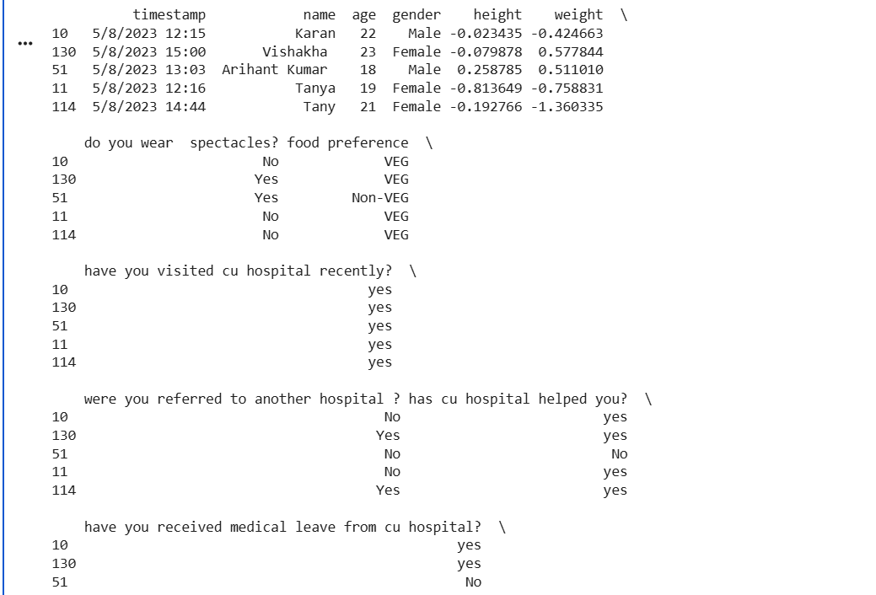


Explanation:
This task aims to clean student health records by filling missing values in key attributes such as height, weight, and BMI. It encodes categorical variables like medical condition and fitness status into numerical form and scales numerical features for uniformity. Finally, the dataset is split into training and testing sets to support predictive health analysis.

Task 4: Real-Time Application: Ride-Sharing Data Cleaning
Prompt:
Process ride-sharing trip data by standardizing location names and handling missing fare values using median imputation. Remove duplicate entries, normalize driver ratings, and generate a summary report of improvements. Prepare the dataset for operational analytics and decision-making.
Before Preprocessing:
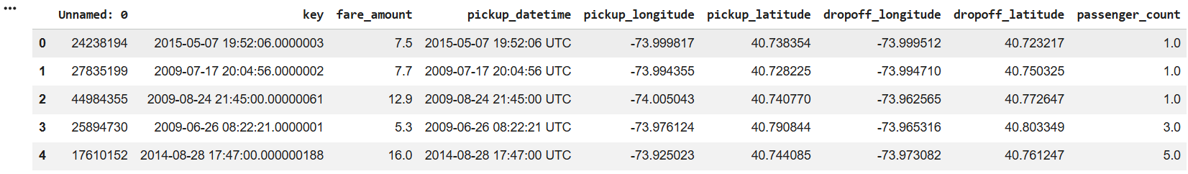

Code:
import pandas as pd
from sklearn.preprocessing import MinMaxScaler

# Load dataset
df = pd.read_csv("uber.csv")

# Standardize locations (lowercase)
df['pickup_datetime'] = df['pickup_datetime'].str.lower()

# Fill missing fare
df['fare_amount'] = df['fare_amount'].fillna(df['fare_amount'].median())

# Remove duplicates
df = df.drop_duplicates()

# Normalize driver rating (create dummy if not present)
if 'driver_rating' not in df.columns:
df['driver_rating'] = 4.0 # dummy constant

scaler = MinMaxScaler()
df['driver_rating_normalized'] = scaler.fit_transform(df[['driver_rating']])

# Summary
summary = {
"Initial rows": len(df),
"Missing values handled": df.isnull().sum().sum(),
"Final rows": len(df)
}

print("Data Cleaning Summary:", summary)

df.to_csv("clean_rides_data.csv", index=False)
df.head()

Output:
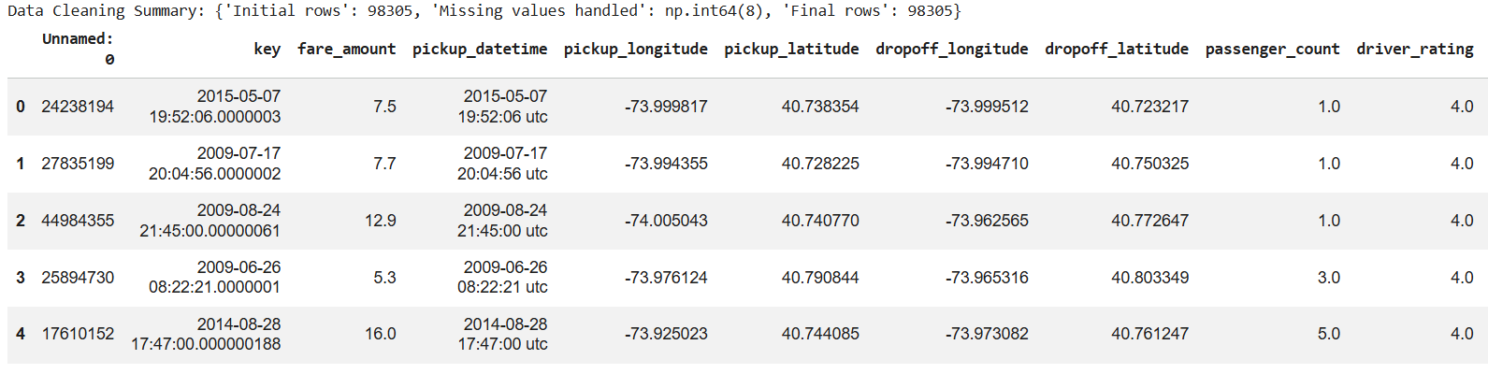

Explanation:
This task focuses on cleaning ride-sharing data by standardizing location information and handling missing fare values using median imputation. Duplicate records are removed, and driver ratings are normalized to ensure consistency across the dataset. A summary of data cleaning improvements is generated, making the dataset ready for operational insights and analytics.

